Page **1** of **2**

**VLAN configuration using Packet Tracer**

http://ipcisco.com/vlan-part-5-packet-tracer-vlan-configuration-example/

PC Configurations

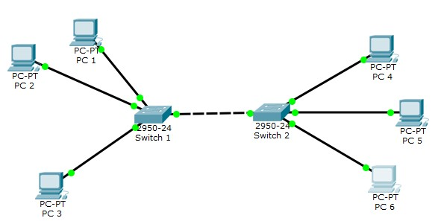

PC 1 -> 192.168.1.2 VLAN 2 PC 2 > 192.168.1.3 VLAN 2 **PC 3 -**

**> 192.168.1.4 VLAN 3 PC 4 -**

**> 192.168.1.6 VLAN 3 PC 5 > 192.168.1.7 VLAN 3** PC 6 -

> 192.168.1.8 VLAN 2

Ping from PC1 to PC6 → successful BUT

Ping from PC1 to PC3 → unsuccessful (VLAN config worked!!!)

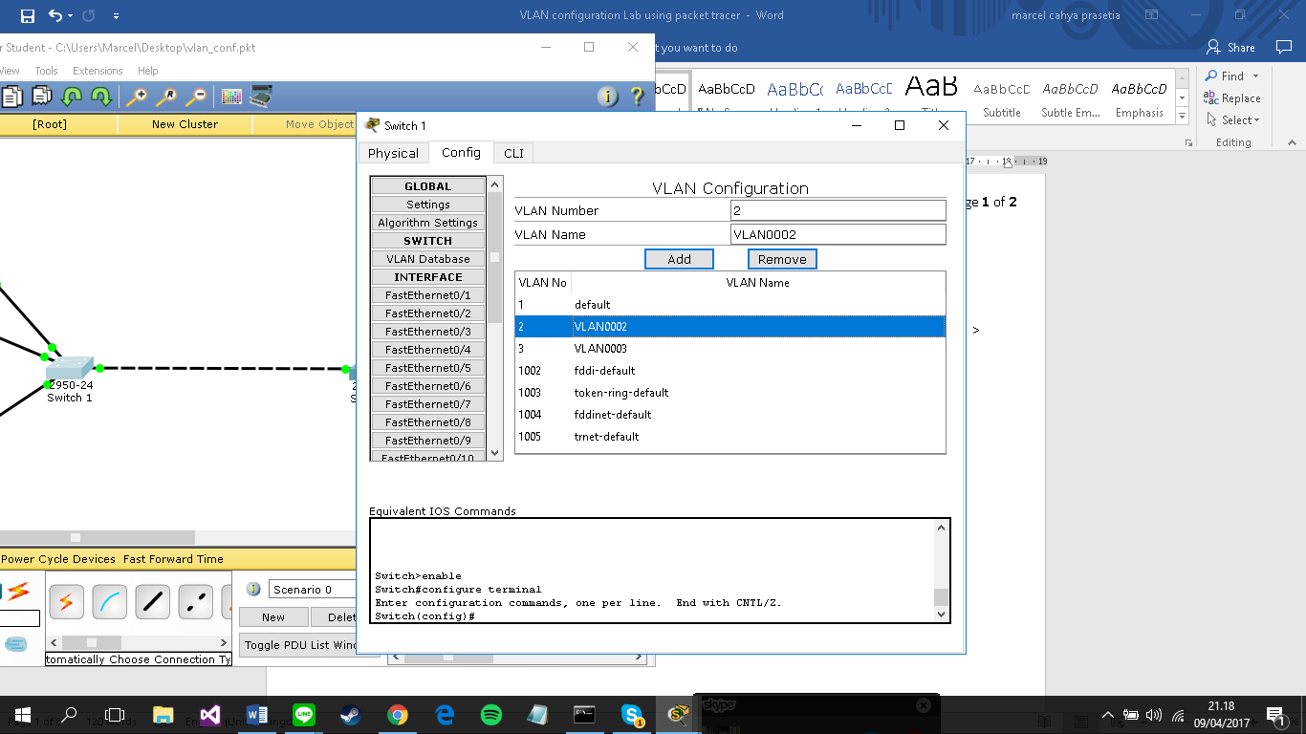

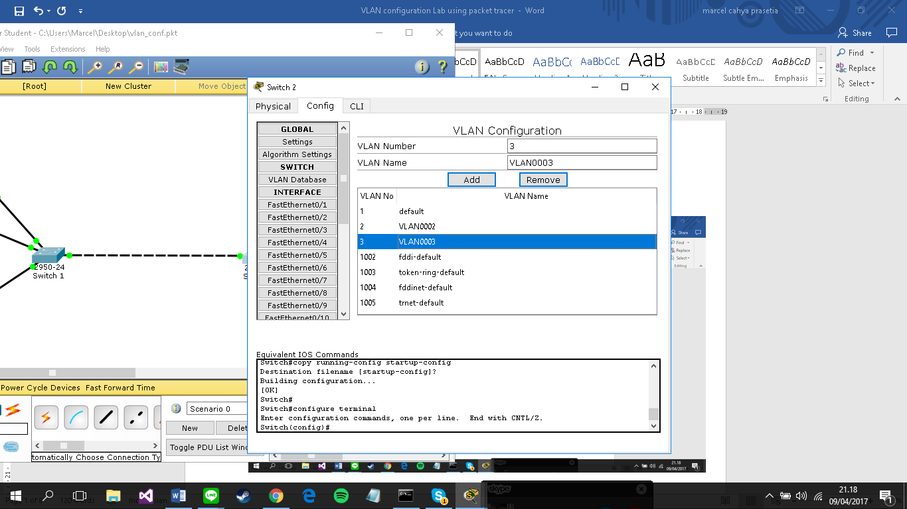

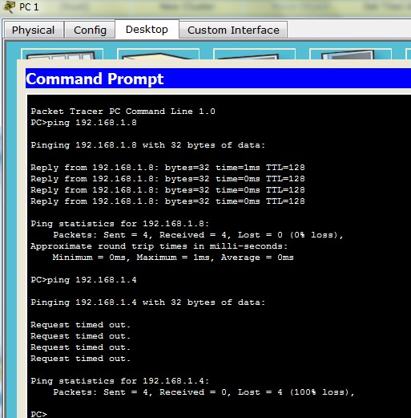

Page **2** of **2**

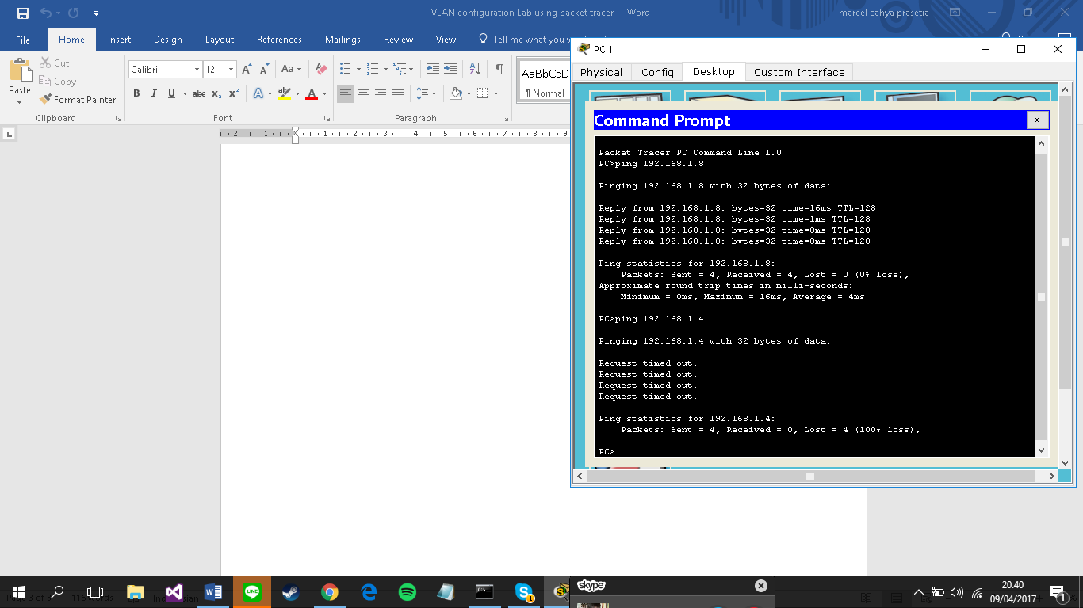

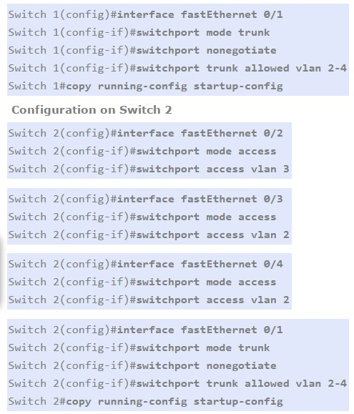

**Configuration on Switch 1**

Switch 1(config)#interface fastEthernet 0/2

Switch 1(config-if)#switchport mode access

Switch 1(config-if)#switchport access vlan 2

Switch 1(config)#interface fastEthernet 0/3

Switch 1(config-if)#switchport mode access

Switch 1(config-if)#switchport access vlan 2

Switch 1(config)#interface fastEthernet 0/4

Switch 1(config-if)#switchport mode access

Switch 1(config-if)#switchport access vlan 3

**Switch 1:**

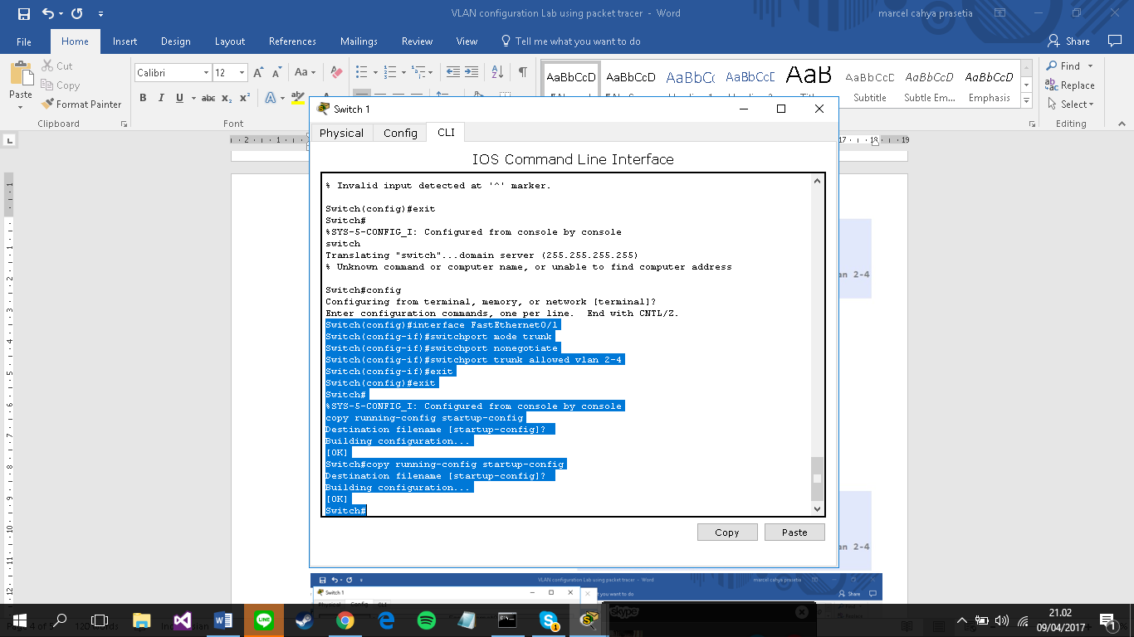

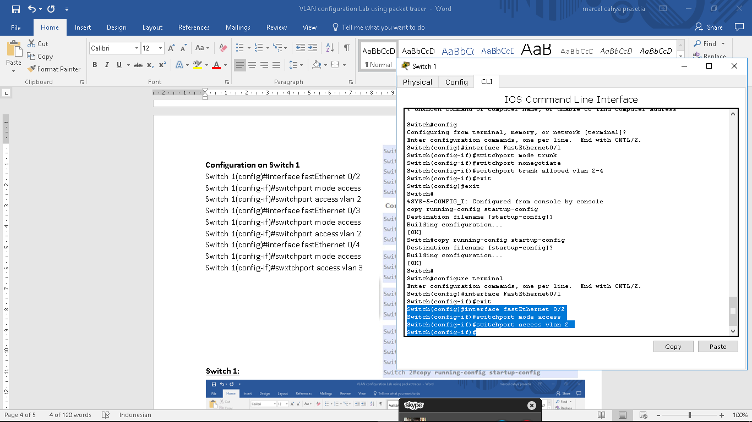

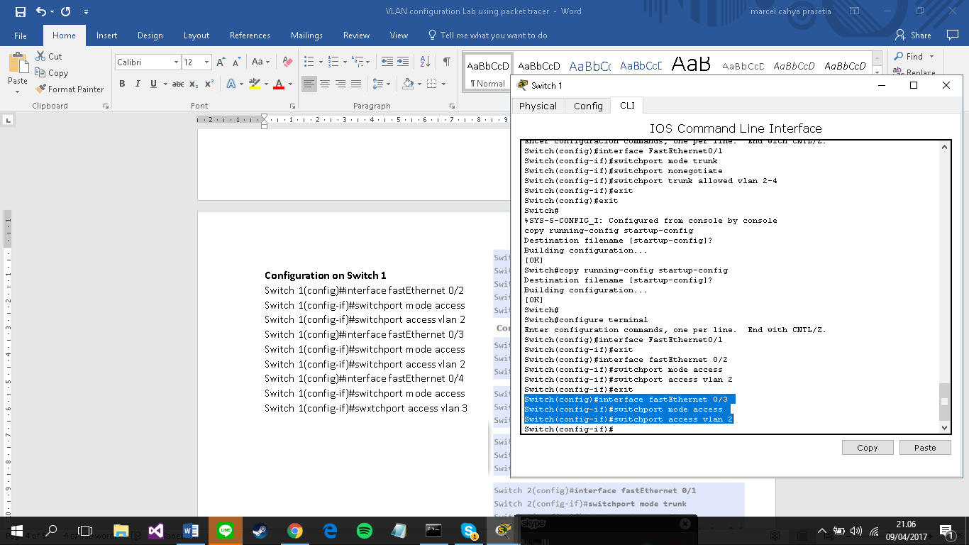

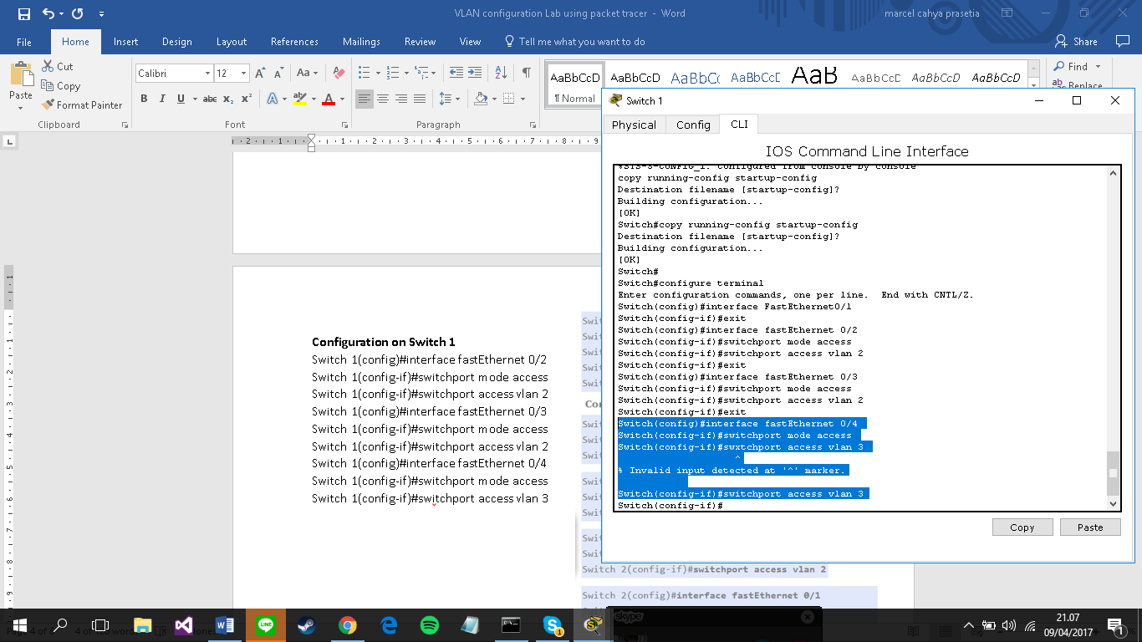

**Switch 2:**

